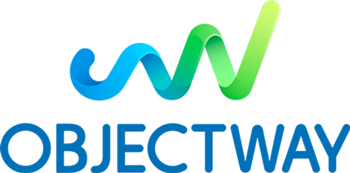

DevOps Developer Internship

Objectway is a Top 100 global FinTech provider and a leader in the Wealth, Investment & Asset Management Software Industry, with more than 700 employees and offices in Italy, UK, Ireland and Benelux.

We are currently looking for a DevOps Developer Intern, who will join our DevOps team.
Becoming a DevOps Developer means being involved in designing, automatically deploying and maintaining our product solution for Fintech world. This figure will work side-by-side with our product development groups, providing relevant tools and supporting architectural decisions based on a DevOps mindset. We aim to form a DevOps engineer, who will permanently join our company.
Activities
During this internship, the activities you may undertake include:
Microservices and container architecture (Docker)
Container orchestrators (Rancher, Kubernetes)
Code versioning systems (Git, Mercurial) and CI/CD frameworks (Jenkins)
Different scripting (bash, batch) based on Linux/Unix platform and Windows
Cloud Platform (Google Cloud, AWS) and related tasks
Requirements
Hold a Bachelor’s degree in Computer Science, Computer Engineering or related subjects
Strong interest in developing computer programming as a competency
Knowledge of Object-Oriented development.
Be a fast learner, able to handle stress and be a team player
Attitude in problem solving and troubleshooting
We offer
A six-month internship that enables you to put your theoretical knowledge into practice to gain on-the-job experience
At the end of the program will be offered a full-time employment contract
This role provides you a unique opportunity to develop your career
Paid internship: 1000€ per month

You can apply for this position at https://careers.objectway.it/job?id=70 or sending an e-mail to jobs@objectway.it deadline 30.01.2020
PLEASE FIND ON OUR WEBSITE THE OBJECTWAY PRIVACY POLICY.
Objectway is an equal opportunity employer.

Approximate start date: 30. January

