ICT Strategy and Models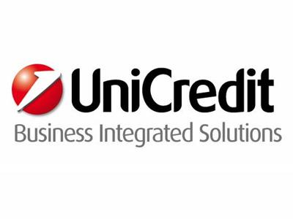
- Vacancy Type: Graduate
- Job Area: Information Technology
- Location: Lombardia-Milano
Area description
UniCredit Business Integrated Solutions (UBIS) is an ICT company that operates on a global level as the main ICT service provider for UniCredit. With 19 locations in 8 European companies, UBIS is the provider for all technological and organisational solutions.
Function description
In the perimeter of Banking Service Lines Management, within UniCredit Business Integrated solutions ScpA, SL “ICT” manages, directly or indirectly, all ICT related topics including development and
maintenance of solutions - in accordance with the Group Guidelines - providing state-of-the-art economically sustainable infrastructure to customers and to the Company and guaranteeing ICT services enabling the Business. Moreover, is directly responsible to manage UBIS ICT internal services with focus on quality and cost optimization through the continuous research of efficiencies in run and change delivery.
Job description
Main activities:
• Definition of the ICT strategy for the Service Lines, in alignment with the evolution of the business model of our clients and under consideration of best practices in the industry;
• Ensure the sustainability of the ICT strategy;
• Ensure a holistic view on all relevant ICT topics which have an mid- to long-term impact on the positioning of ICT in order to define strategic options for the Service Line. This includes all technological and organizational aspects of the Service Line like methodologies, models, industrial processes and quality;
• Managing organizational and process-related projects;
• Monitoring the quality of services delivered by the Service Line;
• Monitoring the implementation of the strategy and guidelines in the Service Line.

What we expect from you
- Analytical skills
- Collaboration and team work aptitude
- Fluent English (written and spoken)
- International mindset
- Project management skills
- Willingness to travel
- Degree in Engineering

What we offer to you
If you are looking for an international career in the Technology sector, UniCredit Business Integrated Solutions is the right place for you! You will be challenged with an unique experienced to foster your charisma and creativity, technical competences but also team spirit and continuous learning attitude.

- Entry date: 20/01/2016
- Contract Type: Apprenticeship

