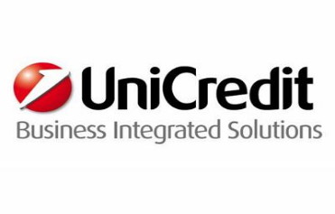

IT Business/Technical Analyst - Securities Services
Vacancy Type: Graduate
Job Area: Information Technology
Location: Milano 3701
Area description
UniCredit Business Integrated Solutions (UBIS) is an ICT company that operates on a global level as the main ICT service provider for UniCredit. With 19 locations in 8 European companies, UBIS is the provider for all technological and organisational solutions.
Function description
PL "Core Banking & Securities” integrates and manages both application solutions and Operations components in order to act as a single reference point for all customers within the Core Banking (i.e. clients’ current accounts, term deposits and savings accounts, master data management, legal and fiscal investigations, etc.) and Securities in Mature countries. Moreover, for Czech Republic it manages the applications used for Core Banking activities (i.e. clients’ current accounts, term depositsand savings accounts, etc.).
Job description
Key tasks and responsibilities:
The ideal candidate will be responsible for analysis, design and implementation, dealing with integration within different modules of in-house Java-based applications within a dynamic multibank international context.

What we expect from you
- Ability to handle stress and high tolerance to tight schedule
- Analytical skills
- Collaboration and team work aptitude
- Efficiently communicate verbally and writing
- Good level of english (written and spoken)
- Problem solving
- Degree in Engineering, Informatics, Mathematics, Physics
- Good knowledge of Java language
- Minimum basic knowledge of DataBase design
- Banking and financial general knowledge (Securities)
- Business Requirements understanding , analysis and interpretation of business/functional specification
- Functional Analysis in complex business environment
- Test case
- Business processes designing

What we offer to you
If you are looking for an international career in the Technology sector, UniCredit Business Integrated Solutions is the right place for you! You will be challenged with an unique experienced to foster your charisma and creativity, technical competences but also team spirit and continuous learning attitude.
- Entry date: 25/07/2016
- Contract Type: Apprenticeship
- Career website: www.careers.unicreditgroup.eu
Il candidato interessato dovrà inserire il suo curriculum sul sito UniCredit, accedendo a questo link: https://career012.successfactors.eu/career?company=Unicredit entro il 31.08.2016

